Search Terms：

("opinion mining" OR "sentiment analysis" OR "Aspect-based sentiment analysis" OR "SA" OR "ABSA") AND ("requirements elicitation" OR "requirements discovery" OR "requirements acquisition" OR "requirements specification" OR "requirements gathering" OR "requirements capture") AND ("users' reviews" OR "comments" OR "online reviews" OR "APP reviews" OR "applications" OR "software" OR "app" OR "app store")

Inclusion and exclusion criterion.
No. | Inclusion criterion | No. | Exclusion criterion
I1 | The paper is written in English. | E1 | The paper is an example of gray literature, e.g., a technical report or non-public dissertation.
I2 | The paper was published between January 2013 and February 2023. | E2 | The paper is not from a conference or journal.
I3 | The paper is available in full text. | E3 | The paper is a brief paper, a position paper, or an editorial
I4 | The paper that focuses on using sentiment analysis/opinion mining technology in app reviews or suggestions for requirements elicitation. | E4 | The subject of the paper is a secondary study
- | - | E5 | The paper that does not concentrate on using sentiment analysis/opinion mining technology in app reviews or suggestions for requirements elicitation

RQs
Index | Descriptions
RQ1 | What are the authors/venues/dates of these studies?
RQ2 | Which existing datasets are used during the experimental phase?
RQ3 | How can SA techniques support requirement elicitation?
 | RQ3.1 Which types of SA are used?
 | RQ3.2 How do the SA processes affect the results?
 | RQ3.3 Which techniques or tools are used at different stages of the processes?
RQ4 | Which measures are used to evaluate performance in primary studies?
RQ5 | How about the quality of these primary studies?

Inclusion and exclusion criteria:
No. | Inclusion criterion | No. | Exclusion criterion
I1 | The paper is written in English. | E1 | The paper is an example of gray literature, e.g., a technical report or non-public dissertation.
I2 | The paper was published between January 2013 and February 2023. | E2 | The paper is not from a conference or journal.
I3 | The paper is available in full text. | E3 | The paper is a brief paper, a position paper, or an editorial
I4 | The paper that focuses on using sentiment analysis/opinion mining technology in app reviews or suggestions for requirements elicitation. | E4 | The subject of the paper is a secondary study
- | - | E5 | The paper that does not concentrate on using sentiment analysis/opinion mining technology in app reviews or suggestions for requirements elicitation

TECH report & Statistics：
- https://link.springer.com/

("opinion mining" OR "sentiment analysis" OR "Aspect-based sentiment analysis" OR "SA" OR "ABSA") AND ("requirements elicitation" OR "requirements discovery" OR "requirements acquisition" OR "requirements specification" OR "requirements gathering" OR "requirements capture") AND ("users' reviews" OR "comments" OR "online reviews" OR "APP reviews" OR "applications" OR "software" OR "app" OR "app store")
1535
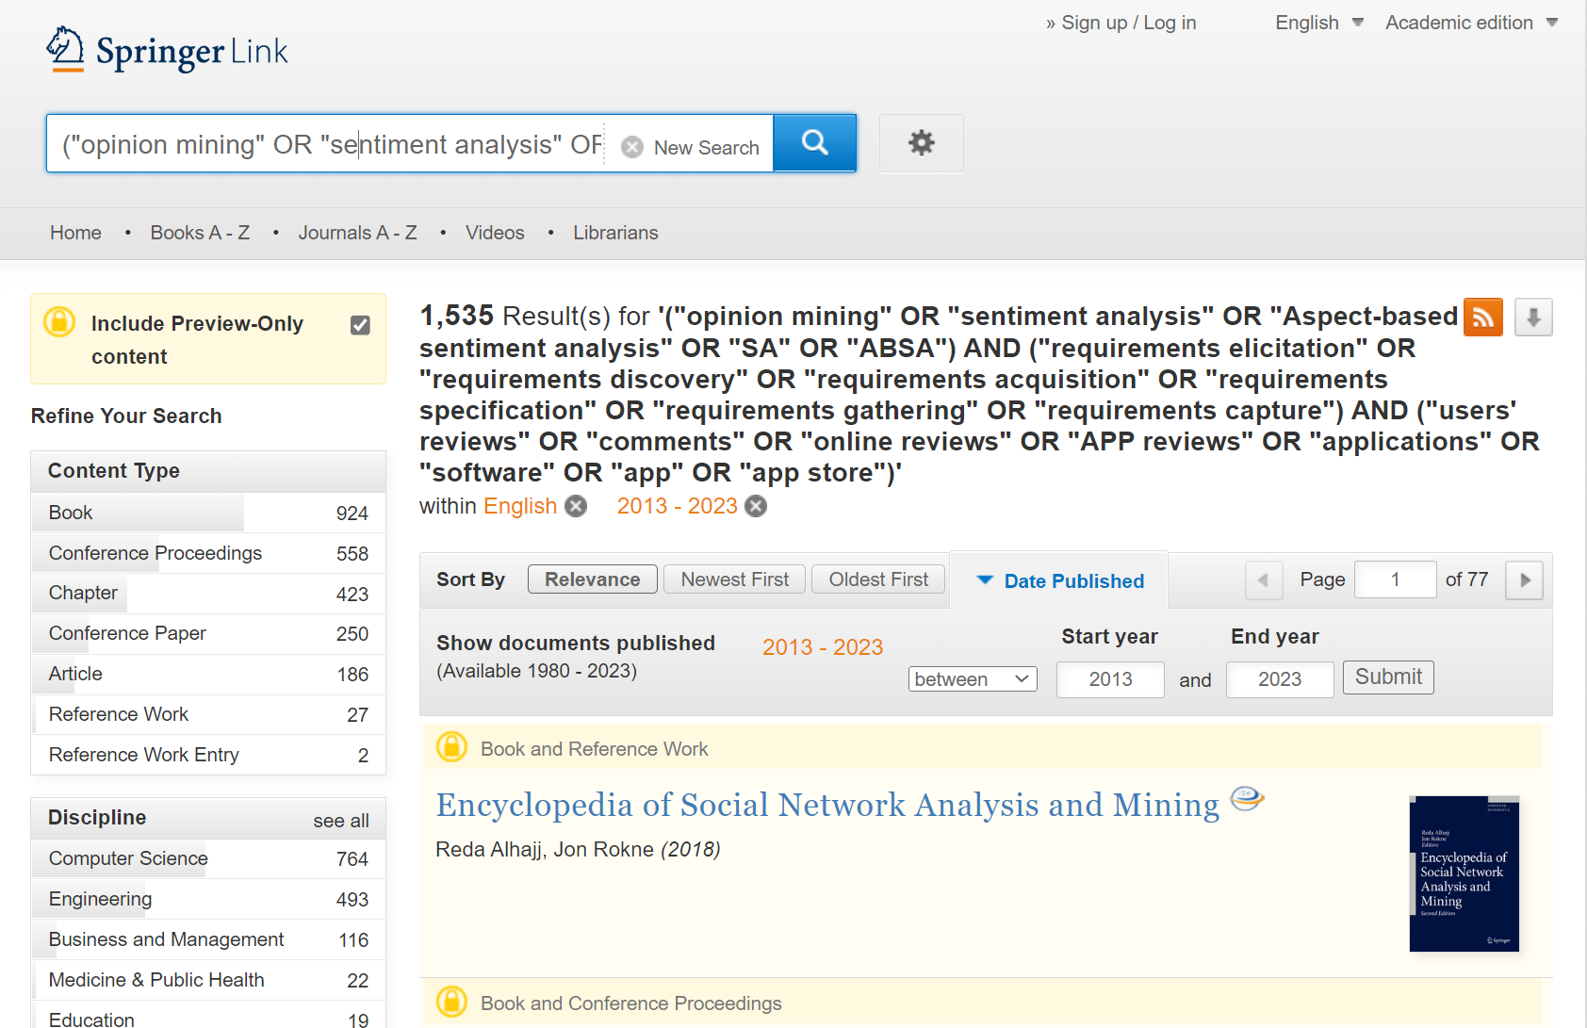
- ACM Digital Library

https://dl.acm.org/

[[All: "opinion mining"] OR [All: "sentiment analysis"]] AND [[All: "requirements elicitation"] OR [All: "requirements discovery"] OR [All: "requirements acquisition"] OR [All: "requirements specification"] OR [All: "requirements gathering"] OR [All: "requirements capture"]] AND [[All: "users' reviews"] OR [All: "comments"] OR [All: "online reviews"] OR [All: "app reviews"] OR [All: "applications"] OR [All: "software"]]
321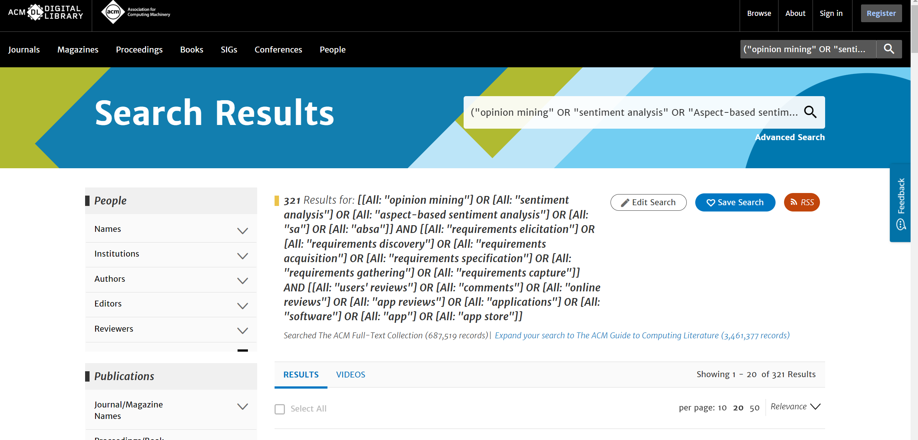
AND [E-Publication Date: (01/01/2013 TO 02/28/2023)]

150
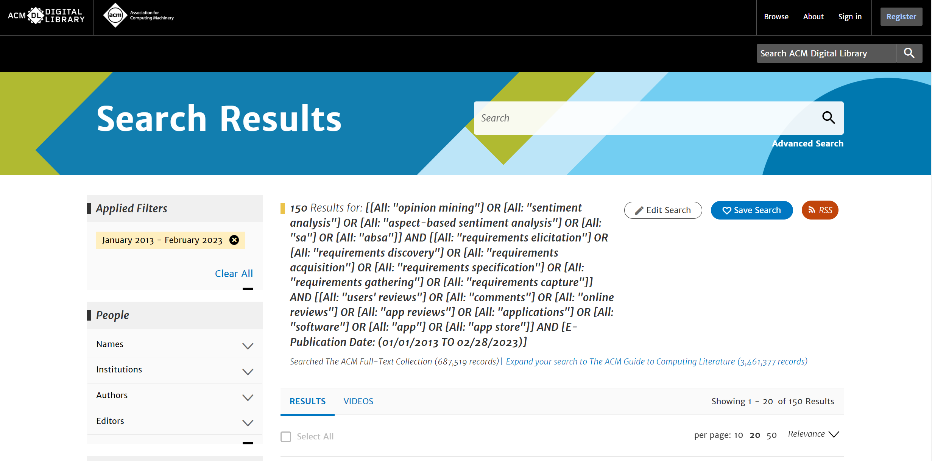

- Elsevier ScienceDirect

https://www.sciencedirect.com/

("opinion mining" OR "sentiment analysis" OR "Aspect-based sentiment analysis" OR "SA" OR "ABSA") AND ("requirements elicitation" OR "requirements discovery" OR "requirements acquisition" OR "requirements specification" OR "requirements gathering" OR "requirements capture") AND ("users' reviews" OR "comments" OR "online reviews" OR "APP reviews" OR "applications" OR "software" OR "app" OR "app store")

Due to the fact that Elsevier ScienceDirect does not allow more than 8 associated words to be retrieved, the search terms are divided into 4 groups and deduplicated
Group1:
("opinion mining" OR "sentiment analysis" OR "Aspect-based sentiment analysis") AND ("requirements elicitation" OR "requirements discovery" OR "requirements acquisition") AND ("comments" OR "online reviews" OR "app store")

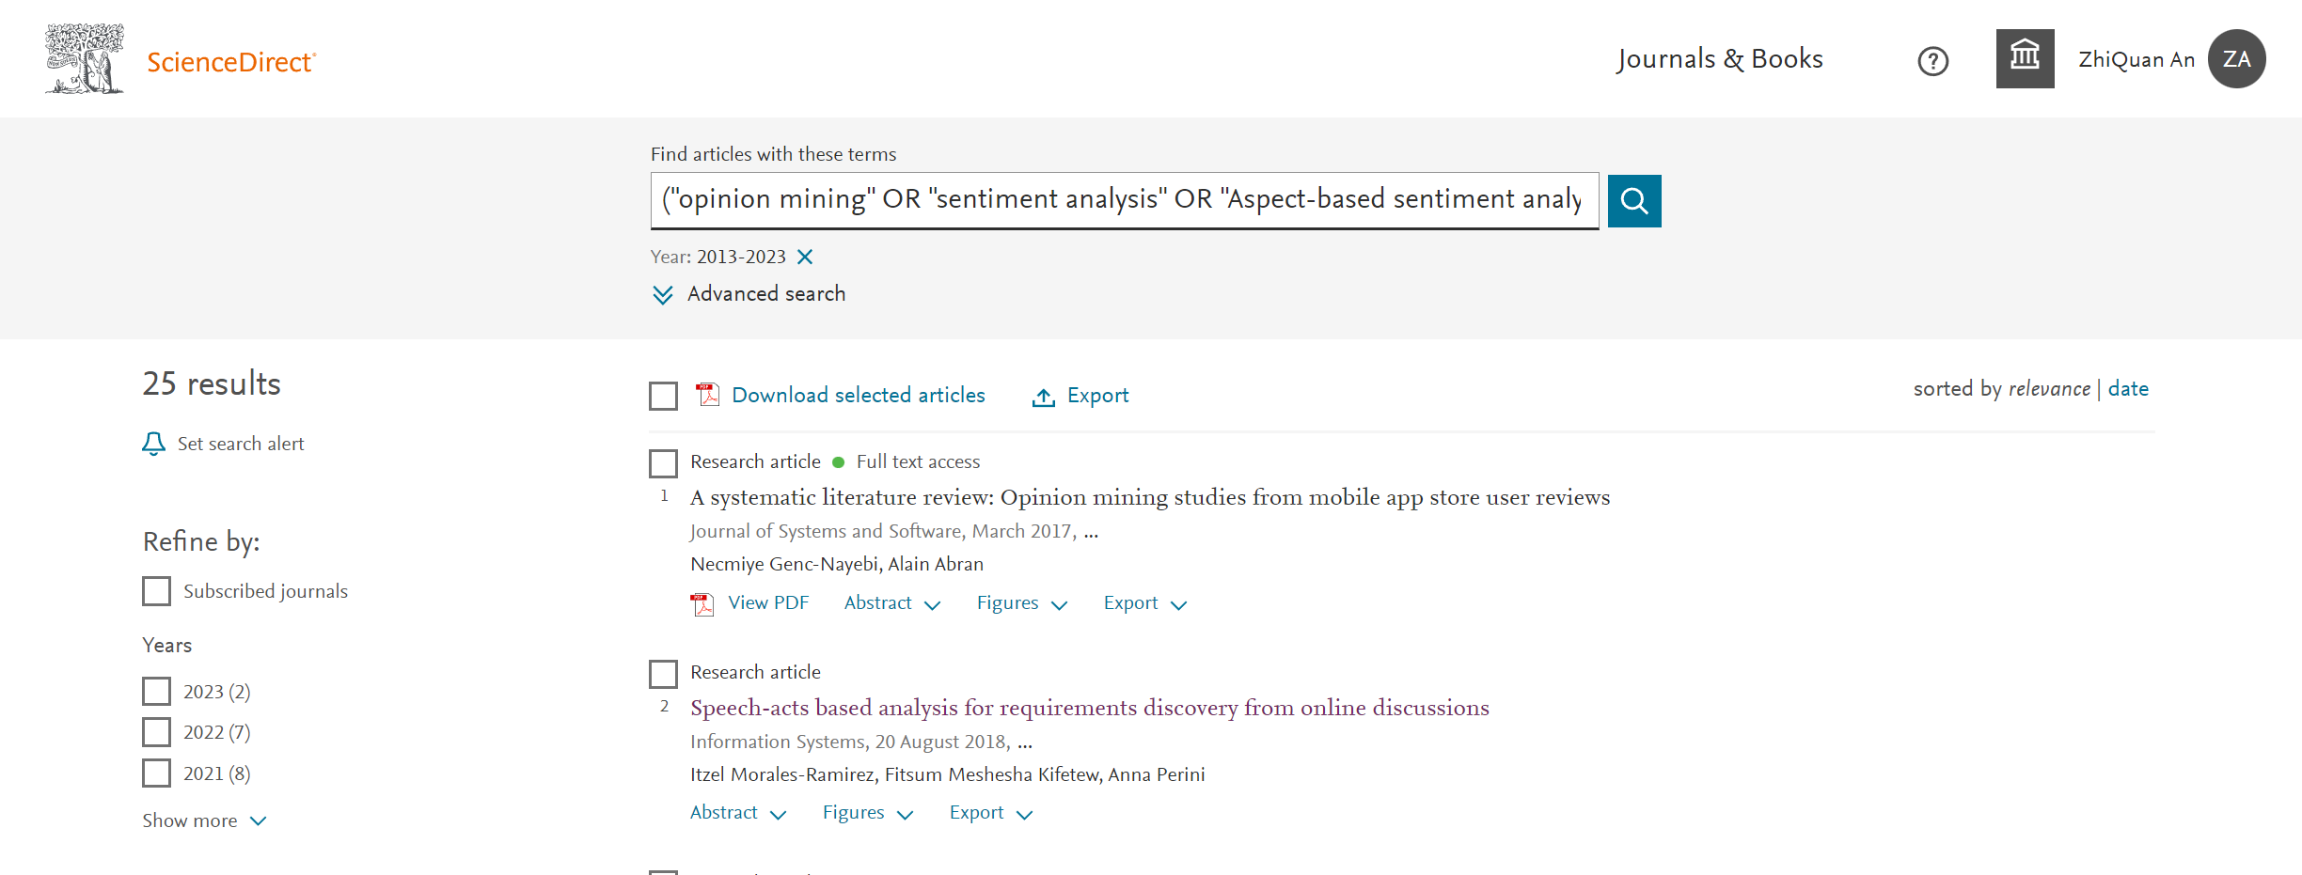

Group2:
("opinion mining" OR "sentiment analysis" ) AND ("requirements elicitation" OR "requirements specification" OR "requirements gathering" OR "requirements capture") AND ("users' reviews" OR "APP reviews" OR "app")

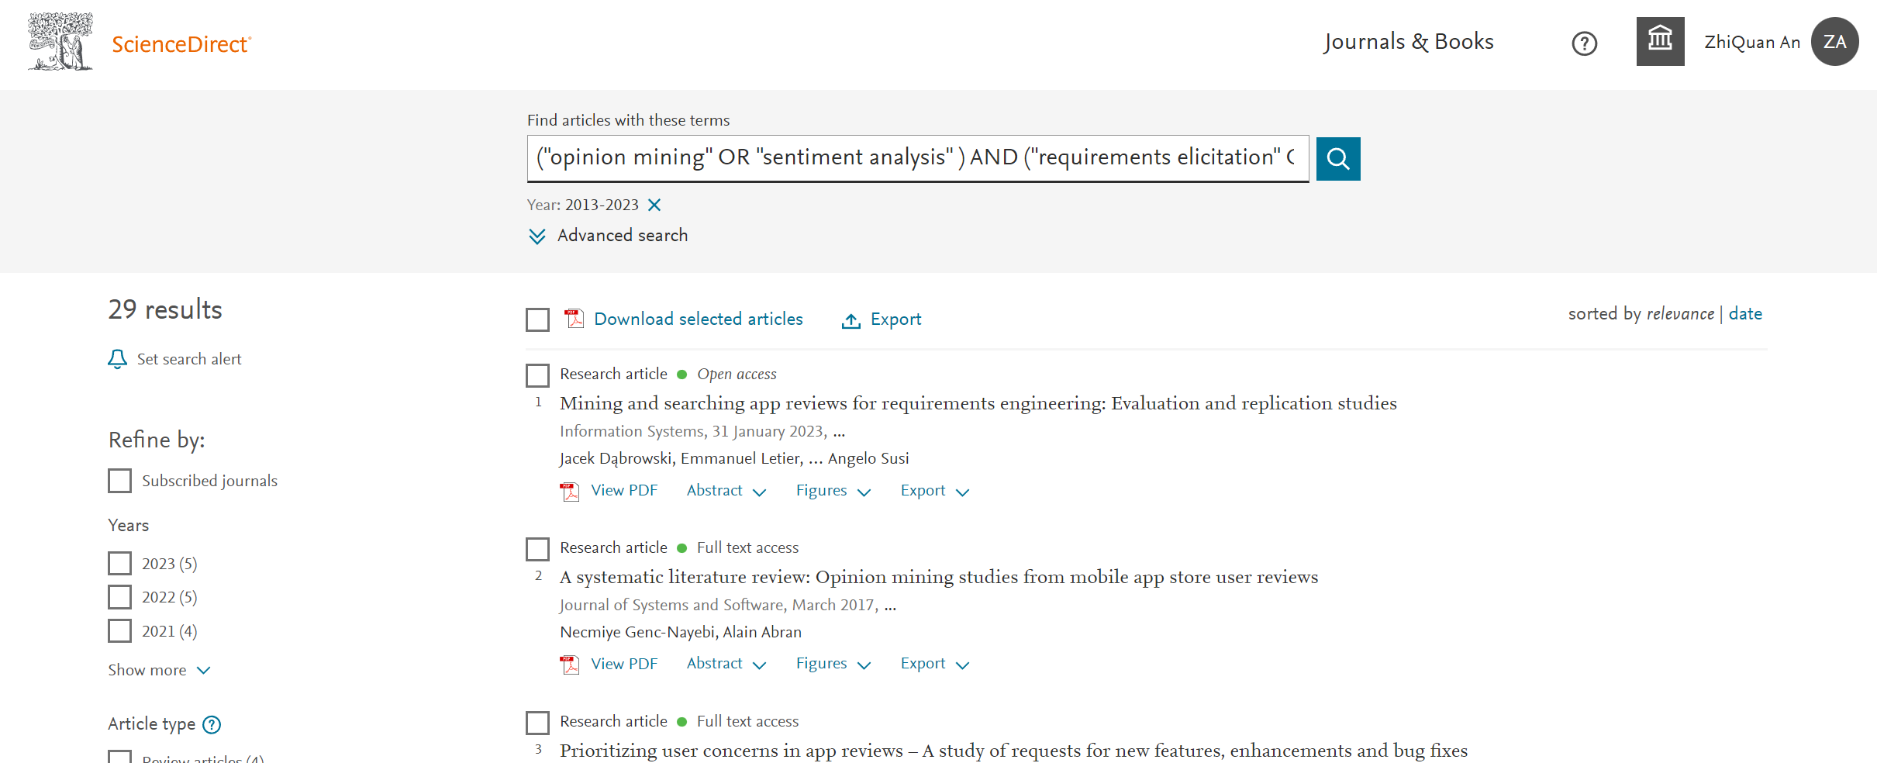

Group3:
("opinion mining" OR "sentiment analysis" OR"ABSA" ) AND ("requirements elicitation" OR "requirements capture") AND ("applications" OR "software" OR "APP reviews" OR"comments" )
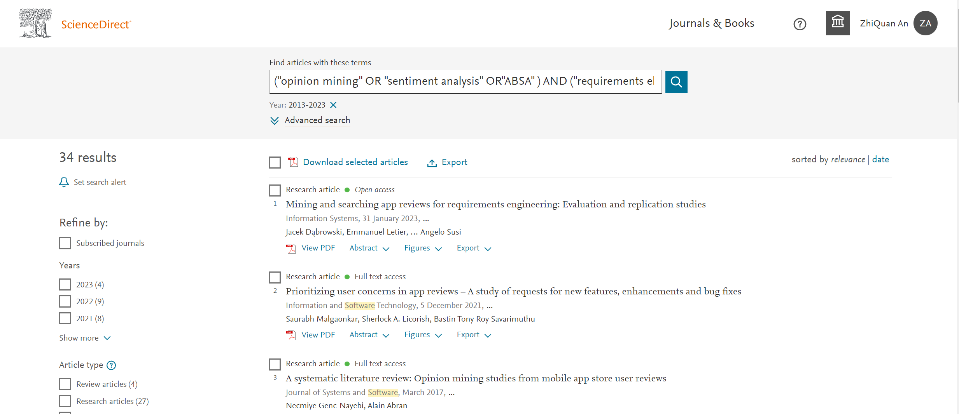
Group4:
("opinion mining" OR "sentiment analysis" OR"SA" ) AND ("requirements elicitation" OR "requirements discovery" OR "requirements acquisition" ) AND ("APP reviews" OR"comments" OR "users' reviews" )

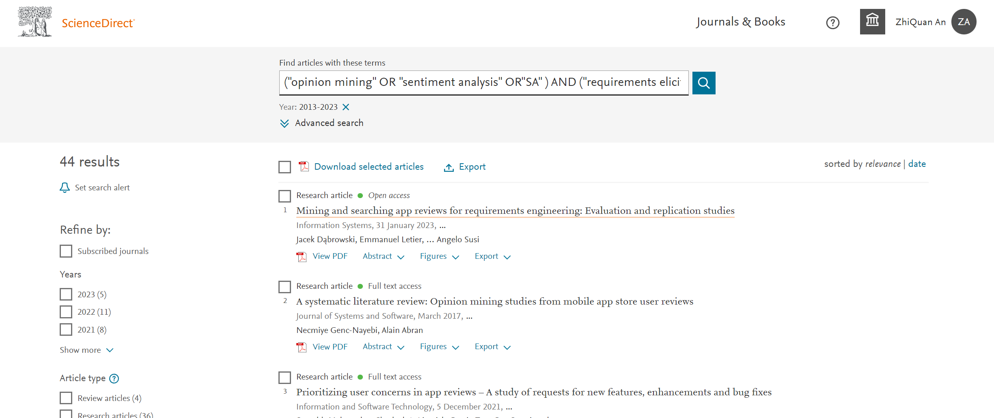

Merge and De-duplication : 63

- EI
https://www.engineeringvillage.com/

("opinion mining" OR "sentiment analysis" OR "Aspect-based sentiment analysis" OR "SA" OR "ABSA") AND ("requirements elicitation" OR "requirements discovery" OR "requirements acquisition" OR "requirements specification" OR "requirements gathering" OR "requirements capture") AND ("users' reviews" OR "comments" OR "online reviews" OR "APP reviews" OR "applications" OR "software" OR "app" OR "app store")

WN KY

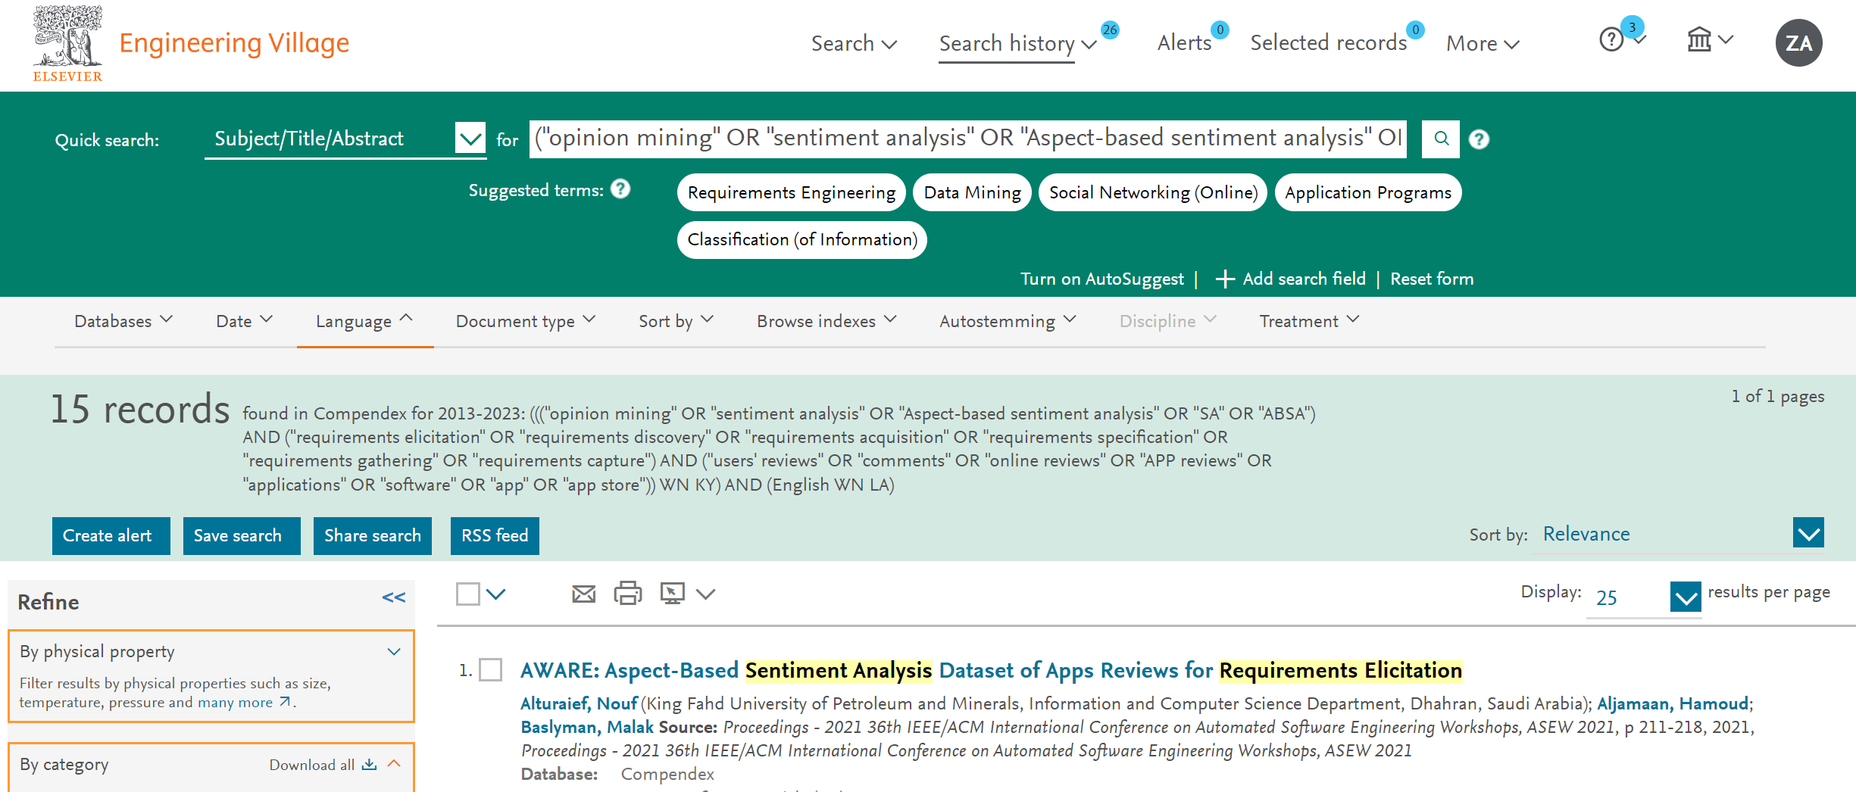

WN ALL
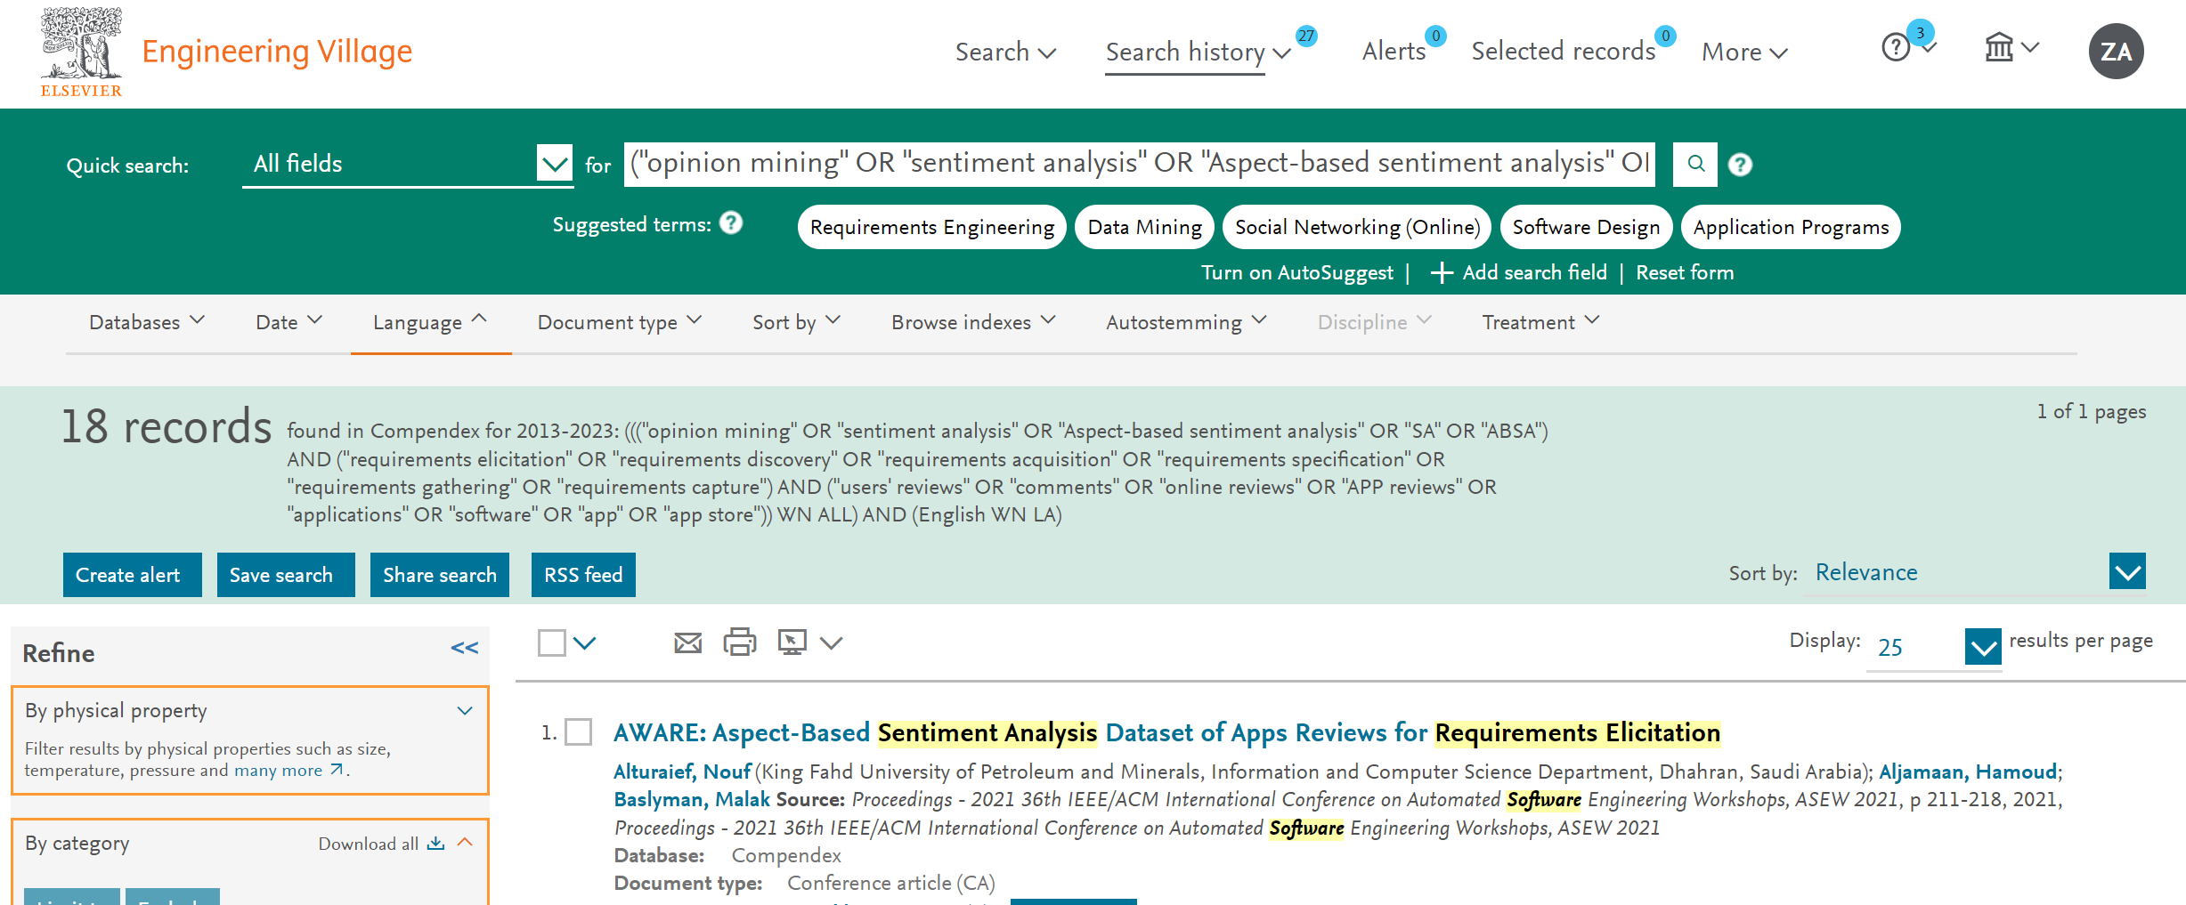

Merge and De-duplication：18

- IEEE
https://ieeexplore.ieee.org/
("All Metadata":"opinion mining" OR "All Metadata":"sentiment analysis" OR "All Metadata":"Aspect-based sentiment analysis" OR "All Metadata":"SA" OR "All Metadata":"ABSA") AND ("All Metadata":"requirements elicitation" OR "All Metadata":"requirements discovery" OR "All Metadata":"requirements acquisition" OR "All Metadata":"requirements specification" OR "All Metadata":"requirements gathering" OR "All Metadata":"requirements capture") AND ("All Metadata":"users' reviews" OR "All Metadata":"comments" OR "All Metadata":"APP reviews" OR "All Metadata":"applications" OR "All Metadata": "software" OR "All Metadata":"app" OR "All Metadata":"app store")

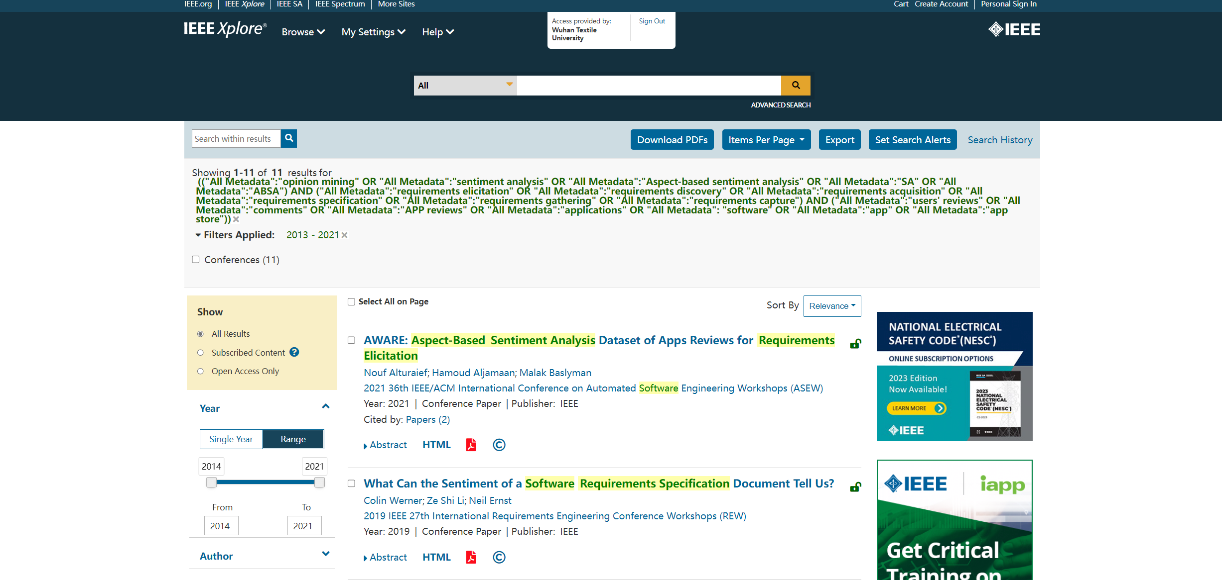
11

- Wiley online library
https://onlinelibrary.wiley.com/

("opinion mining" OR "sentiment analysis") AND ("requirements elicitation" OR "requirements discovery" OR "requirements acquisition" OR "requirements specification" OR "requirements gathering" OR "requirements capture") AND ("users' reviews" OR "comments" OR "online reviews" OR "APP reviews" OR "applications" OR "software") anywhere

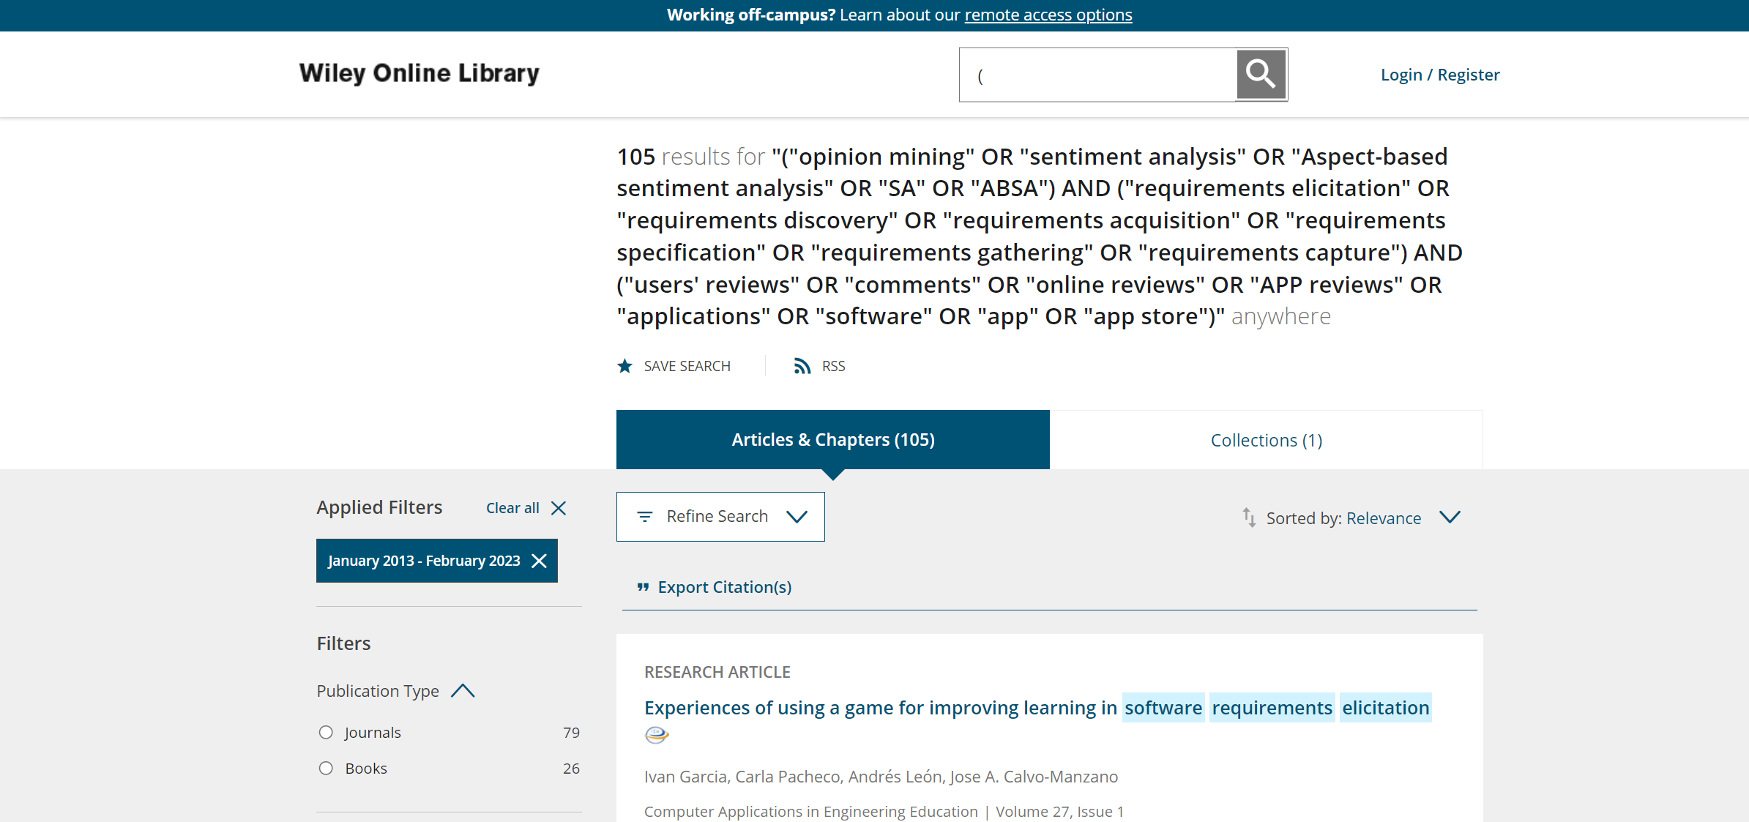
105

Total:
1882
A: Exclude duplicates
740
B: Filter by title
conference/journal not secondary & not gray&ex3&in3: 594
C: Filter by abstract
108
D: Content and QA
Include: 29
E: Snowballing：3

